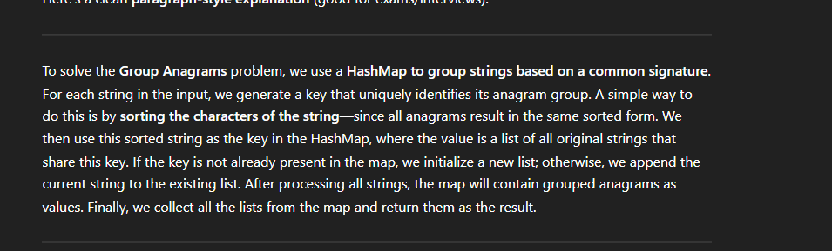
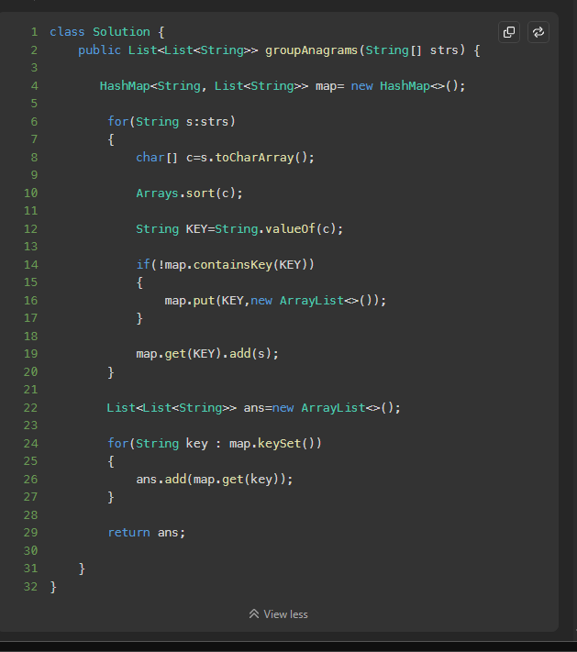

First we take a string from the input given and we covert it to char array and make it as key , if the key already present in the Hashmap then we add the original string as a value , if not present then we add the key into the Hashmap and then add the same as value ;

